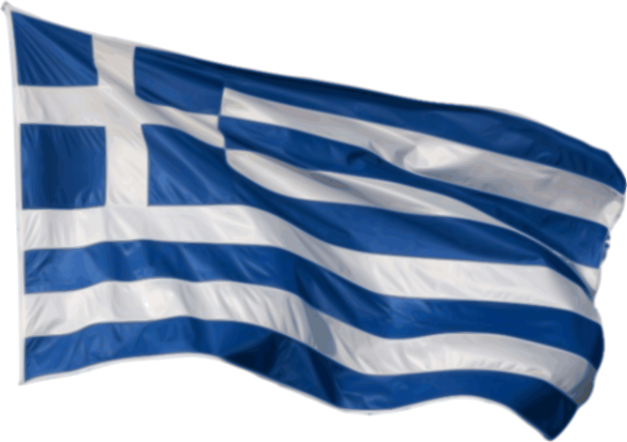
Hello visitors,
This is our podcast for learning the Greek language. Although Greek grammar and vocabulary are difficult to learn – and of course we use another set of characters, we will try to give you the most useful words and expressions in order to communicate with Greek people.
First of all, we call our country Hellas so Greece in Greek is Hellas (Ελλάδα)
If you want to say hello, in our language you would say: Yia (Γεια).
We can say to somebody good morning: Kalimera (Καλημέρα), or good evening: Kalispera (Καλησπέρα)
If you want to ask ‘‘how are you?’’ in Greek you would say: (Pos ise?) Πώς είσαι;
We can also ask what the time is: Ti ora ine? (Τι ώρα είναι;)
When we want to introduce ourselves, we say: My name is Anna: (Me lene Anna) Με λένε Άννα.
After that it would be sure that you would need to say where you live: I live in Thessaloniki: (Meno stin Thesaloniki) Μένω στην Θεσσαλονίκη
If we want to say something about our family as I have a sister: Eho mia aderfi ( Έχω μία αδελφή) or I have a brother: -Eho enan aderfo (Έχω έναν αδελφό).
When you want to express how wonderful something is, we say: Ine poli omorfo!!! (Είναι πολύ όμορφο!!!)
It is sure that if you go for having a lunch at our local restaurants, Greeks would wish you “Cheers”: Stin ugia sou (Στην υγειά σου) literally meaning “here ‘ s to your good health”
We also say Thank you Efharisto (Ευχαριστώ) and Please or you are welcome parakalo (παρακαλώ)
The good bye is the same word with hello: Yia (Γεια)
By: Joanna Katikaridou, Irene Rodiou,
Nikos Kourompinas and Nikoleta Nikolaidou

